Here is some information about Nursery which we hope will be useful to you.

Welcome:
It is lovely to welcome you and your child to Nursery! Over the year, your child will experience new and exciting learning opportunities, and we will help them develop the skills they need to become successful, happy, enthusiastic, independent learners who are ready to start their ‘big school’ learning journey!


Teaching Information:
Mrs Magnall is the Nursery teacher, working alongside two teaching assistants. Miss Bennett works in Nursery on Wednesdays, Thursdays and Fridays. Miss Munro works in Nursery on Mondays and Tuesdays.
On Thursday afternoons the children have PE with our Sports Coach, and PSHE with Mrs Entwistle.

Curriculum:
We follow the Early Years Foundation Stage curriculum. More information about this can be found on the website, including a link to a ‘Parent’s Guide’.
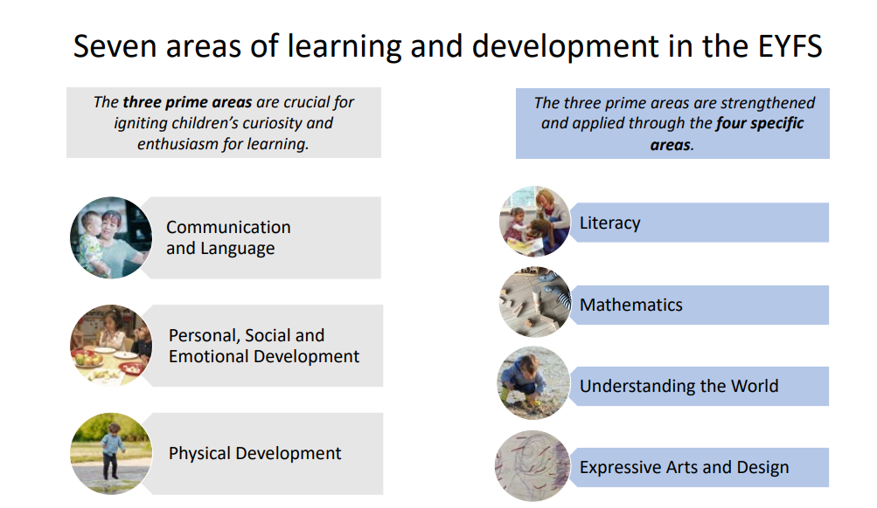

Our ‘Themes’ for this year are as follows:

Autumn 1 | Magnificent Me!
Autumn 2 | Let’s Celebrate!
Spring 1 | All Creatures Great & Small
Spring 2 | Let’s Be Scientists!
Summer 1 | Once Upon a Time…
Summer 2 | Journeys & Adventures

We place great importance on following the children’s lead in terms of their interests and where their individual starting points are and plan learning opportunities based around this. We take time to really get to know your child to enable us to tailor our provision to suit their needs and next steps. Primarily, we will ensure the children have a solid foundation in their personal, social and emotional needs, their physical development and their ability to communicate well and understand language. All the learning we do in Nursery is play-based and fun! Happy learners learn best!

‘Busy Learning’:
During the school day children have what we call ‘Busy Learning’ time. This is when the children have access to resources and activities in the classroom and outside area for them to choose independently. During this time, we may also have adult-led activities which run alongside independent learning.

‘Carpet Time’:
Sometimes we may gather the children together for ‘Carpet Time’. This may consist of a more structured learning activity such as speaking and listening activities or early literacy and numeracy activities. We also finish each Nursery session with a story and singing time all together on the carpet.

Outside Area:
We are very lucky to have a lovely outdoor area just for the Nursery children, they have access to this continuously throughout the day, no matter what the weather, so appropriate clothing is essential. We also have access to the playground equipment and the school grounds, including Forest School.

Phonics:

Our discrete phonics sessions will begin in the summer term. We follow the Ruth Miskin ‘Read, Write Inc’ programme. Further information about this can be found online and on our website.

PE:
PE is every Thursday afternoon and is led by our Sports Coaches. If your child attends this session, they must come to Nursery in their PE kits please. This consists of the green logo T-shirt, black jogging bottoms or leggings, trainers and a black hoodie/zip up top.

Session Times
15 Hours Funding
Morning Nursery session: 8:30am – 11:30am. OR
Afternoon Nursery session: 12:30pm – 3:30pm (collection from 3:15pm to 3:30pm)

30 Hours Funding
Full day session: 8.30am - 2.30pm
Late afternoon session: 2.30pm – 3.30pm- £5 per session

8:30am drop off is at the Nursery gate on the playground.
11:30am pick up is at the side gate by the car park.
12:30pm drop off is at the main office
2.30pm pick up from the main office
3:15pm onwards pick up is at the Nursery gate on the playground.

Although we would never stop parents coming into Nursery in the mornings, we highly recommend that you encourage your child to come in on their own and allow them to hang up their belongings themselves and self-register, to help them develop their independence.

You are more than welcome to approach us about a brief query at the start/end of the day. If there is ever anything you would like to discuss in more detail, please let us know and we can arrange an appointment.

If your child is going to be picked up by anyone other than parents or carers, please let Mrs Magnall or the office know. We cannot let a child go home with an undesignated adult unless told in advance. We ask that you support us in that the children wait to be sent to their parents rather than they run to you on sight. This will ensure that the children go to the correct adults. If a child has not been picked up on time they will be taken to the after-school club, and you will be charged the sessional rate.

Lunchtime Information:

For 15 hours only, we offer an additional lunchtime care from 11:30am – 12:30pm for a small charge.
Packed lunches and hot dinners are eaten in the classroom.

11.30-12.00: Eat in classroom
12.00-12.30: Outside play

Hot dinners – each morning we give the children the options for the day and ask them to choose what they would like. Each day there is a meat option, a vegetarian option and a jacket potato option.

Packed lunches – we encourage healthy eating at Leigh and therefore ask that packed lunches do not contain any chocolate, sweets or fizzy drinks. Please do not include any items containing nuts, including Nutella spread.

We encourage the children to eat but never force them. If your child is not eating much of their lunch, we will always let you know.

Snack:
Fruit and milk are provided at 10:30am and 2:30pm. Each child is entitled to one carton of milk per day. Please let the office know of any allergies or dietary requirements. The children do not need to bring snacks to school.

Water bottles:
Every child has a named water bottle which is kept in Nursery. The staff will fill the bottles up. The bottles are cleaned in school. The children do not need to bring their own water bottle to school.

Toys from home:
We ask that children do not bring in toys from home unless they are specifically asked to for a theme that we are taking part in or an event. If the children do bring things from home, we will keep them to one side until the end of the nursery session, so they do not get broken or lost. If your child has something special to show from home (not a toy) then we ask the parent to complete a ‘Proud Cloud’ and that the teacher be given the item to look after.

Clothing:
Nursery are not required to wear full school uniform, although many choose to do so. However, we do ask that the children wear a green Leigh school jumper.

We would recommend leggings, jogging bottoms, elasticated trousers or skirts that the children can pull up/down themselves. This will also help them become independent with toileting.

Please remember when choosing shoes that the children need to be able to put them on themselves (we recommend Velcro shoes, please no laces!). They have access to outside all the time so sturdy shoes are preferred which cover the whole foot.

Please can you provide your child with a few sets of spare underwear, socks, trousers or skirts in case they happen to have any toileting accidents. We also tend to get a bit messy in Nursery so it’s always useful for the children to have a change of clothes just in case they get a little overenthusiastic with the water, sand, mud etc!! They may also get dirty when we take them out to the Forest School area and will need wellies when it is snowing, raining or muddy please.

Please could you also ensure that your child has a sensible coat, hat and gloves for the winter months and a sunhat and suncream (already applied at home) for the summer months. Please can you name all items of clothing.

Please note that it is very unlikely your child will come home with clean clothing – but they will have learnt something and had a great time doing it!

Toileting:
We expect children starting Nursery to be fully toilet trained unless they have Special Educational Needs or there is a medical reason why they are unable to be independent with their self-care. We will obviously support children with toileting if needed but will help them learn how to become independent with this. We can also support parents with toilet training if necessary and have great links with the Community Nursery Nurse who is able to offer support too. At Nursery we will be asking the children to flush the chain when they have finished in the toilet and to wash their hands afterwards, so please encourage this at home too.

First Aid
Accidents do occur in Nursery, particularly as at this age the children are still developing their motor skills and spatial awareness. All accidents are recorded on a First Aid slip which you will get a copy of when you pick your child up at the end of their session. If a child receives a bump to the head, then a phone call will be made to the parents to inform them of this. Of course, if we do not witness or are not made aware of a tumble, then we do not know it has occurred. We will encourage all the children to come and tell us if they have hurt themselves but occasionally your child may come home and talk about an incident, we were not aware of. Please don’t be alarmed, just come and talk to us if you are concerned.

Absence, Illness and Appointments:
If your child is absent, please phone the school by 9:00am. If we have not received a call, it is likely we will call you to establish why your child is not in school.

We understand that life is unpredictable but being late for school can be unsettling for your child and will affect their learning, so please be on time.

Any hospital, doctor or dental appointments need to be communicated to the school office in advance.

Communication and Parental Involvement:
We place great value on our partnership with parents and strive to ensure you feel informed, valued and part of your child’s education.

MCAS is used to send messages and information. You can download the app on to your phone or tablet or access it on the computer. You will be given a parent join code to set up your account in September. It is quick, easy and we cannot encourage you enough to use it!

We update the Class Page on the school website regularly so please also look at this to see what we’ve been up to in Nursery!

We like to invite you into school regularly to be part of events so look out for what is coming up. Dates and information on these events will be on the school website and we will also send further details home nearer the time of each event.

The school will also send you emails to give you information and keep you updated about dates coming up in the form of a weekly newsletter. There is also a school Facebook page where we share information.

Please send in a ‘Proud Cloud’ if your child has done something brilliant such as learnt to ride a bike, helped make dinner, tidied their bedroom - anything that has made you say ‘wow’! It will be displayed on the wall and be shared with the class. If you need more Proud Clouds please let one of the team know.

Please Email the office if you need to speak to the teacher and a phone call or meeting can be arranged. As mentioned previously, one of the team will also always be available to talk to briefly at the Nursery gate at the beginning and end of the day too.

We are dedicated to working with you to ensure your child is supported and motivated to make as much progress as possible while they are in Nursery. If at any point we are concerned about your child’s development, we will share this with you openly and honestly. Equally, please come and see us if you have a concern. We welcome your involvement in your child’s journey with us and we may ask for your help. If we require this, we will send a letter home.

Thank you for taking the time to read this. We look forward to working with you!







