Telling Tales: YEAR 3 / 4

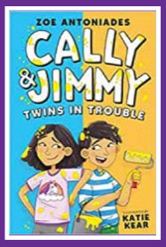
Twins in trouble

Meet twins Jimmy (real name Dimitri) and Cally in these 4 stories where they get into scrapes together, bake some poisonous cakes, almost ruin their school assembly and finally have a twintastic birthday party. Start of a new series, illustrated collections of funny short stories about the twins.

Space detectives

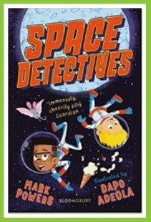
Connor and Ethan are spending their holidays aboard the world's first orbiting city, Starville. But when they discover the space station is hurtling on a collision course with the moon, they know this is a case for the space detectives.

Monster Max and the bobble hat of forgetting

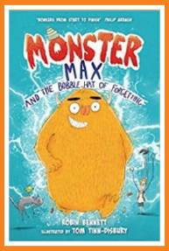
Max is just an ordinary, slightly scruffy boy, until he burps, when he turns into a huge monster, with teeth like swords, who can jump over buildings, roar and eat whole dustbins. It's great being a monster whose aim is to 'protect and do good stuff' until Max sneezes, when he turns back into a boy again, sometimes far from home and dressed only in his pants. But something starts causing a lot of damage in his quiet suburb and it isn't Max. Trailed by his nemesis, Peregrine, a boy his age who has invented a POOP (portable operating omni prison) machine to catch the monster, Max has to find the real culprit before Peregrine catches him...

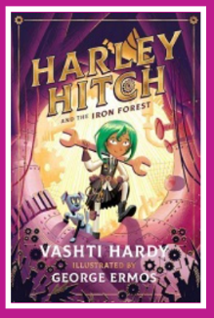
Harley Hitch and the iron forest

Join Harley, her robot dog Sprocket and best friend Cosmo for problem-solving adventures and mysteries in Inventia, a world where science rules and technology grows in the forest; and where exploding science projects, giant slugs and runaway robots are all part of a normal school day. The Iron Forest near Harley’s home is unlike any other – plants and trees grow cogs and hinges and other mechanical parts – and all of Inventia depends on it. So when a strange fungus is discovered, there’s a race to find a solution. Without essential parts for inventions, the town is quickly falling apart.

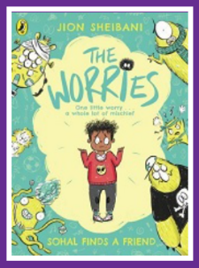
Sohal finds a friend

Sohal worries about a lot of things: the dark, mutant sheep, being alone - you name it, he worries about it! So one night he tries drawing his worries to make himself feel better - and somehow they look a lot less worrying once they're scribbled down. But then imagine Sohal's surprise when he wakes up the next morning to find a set of funny, furry friends at the end of his bed! His worries have come to life, and it's not long before Hurt, Fail, Anger, Big and Alone have turned his world upside down. Now it's up to Sohal to work out how to keep his worries under control - and have some serious fun while he's at it!

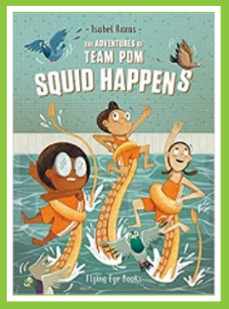
Squid happens

When oddballs Agnes, Roberta and Ruby discover a mutual passion for synchronised swimming, the trio form Team Pom. But between snack time, their favourite TV show and raising pigeons, it can be hard to find time to practice. Tired of their last place, loser status, a crew of self-proclaimed weirdos start their own synchronised swimming club. But on their way to gain the respect and free snacks they deserve, they stumble upon a lonely giant squid in their local pool. Will he be the secret weapon they need to propel them into synchronised swimming super stardom?

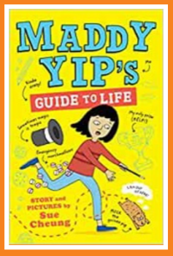
Maddy Yip's guide to life

Maddy Yip is happy in life, until she realises that everyone has a talent - except for her! Maddy is determined to change that, with the help of her brothers, bewildered grandad and her best friend Dev. There are disastrous attempts at breakdancing and playing the recorder, revolting cakes, and a magic disappearing trick that ends up with an escaped guinea pig. This is very funny and full of Cheung’s cartoonlike illustrations. An entertaining read that also gives an insight into a different culture.

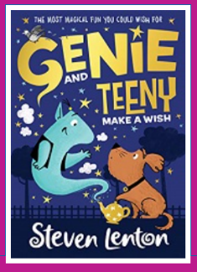
Genie and Teeny make a wish

Grant the Genie is cast out of Genie World and is lonely until he meets Teeny the puppy. But when they are kidnapped by the evil Lavinia Lavender can they foil her evil dog-grooming plans?

