YEAR 5 / 6: Hooked on Books

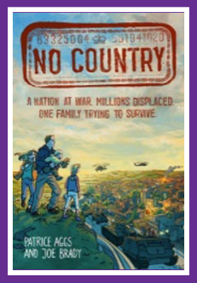
No country

Bea is trying to live a normal life with her family. But she and her family aren't allowed to leave the community they live in. The country is at war around them, and everyone's looking for a way out. Set in Britain where the Prime Minister has used military force to become a dictator and a brutal totalitarian military regime are opposing him, leading to civil war. A scarily believable dystopian future Britain in graphic novel form.

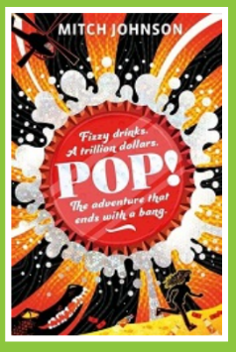
Pop!

An outrageous theft. A huge reward. Two friends on the run. An uproariously funny, action-packed new adventure about the power of courage, standing up for what's right, and fizzy drinks, from the award-winning author of Kick. Queenie stares out at the ocean and dreams of a world beyond her small-town. She's about to get her wish...

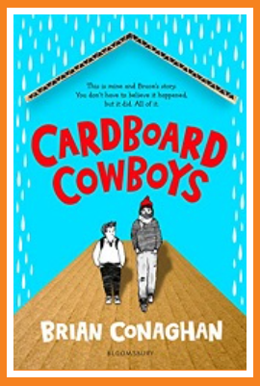
Cardboard cowboys

Nobody at school can see past Lenny's size to the person within. So when lessons get too tough, Lenny always goes to his bench to think. At least there no one can see him. Then one day, midway through lobbing his empty can of Irn-Bru into the canal he's stopped by Bruce. Bruce lives in a cardboard home hidden away by the banks, and he doesn't approve of kids messing up his front lawn ... But a bumpy start soon gives way to an unexpected friendship - and an epic road trip - that will change both of them for life ...

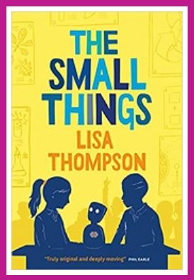
The small things

Anna’s anxious when she’s picked to befriend the new girl in her class. For a start, Ellie is ill and can’t come to school herself. So Anna has to communicate with her through a new kind of robot. But Anna is also worried that her life’s too small and boring to be of interest to her new friend. Compared to the other girls, she doesn’t have anything exciting to talk about and so when Ellie asks her a question, a little white lie pops out. Then another and another. When Ellie finds out the truth, can their friendship survive?

When the Sky Falls
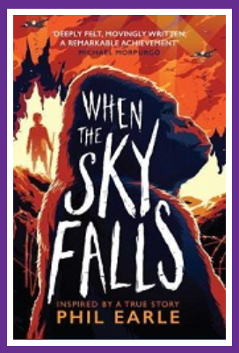

It's 1940, and Joseph is full of anger at being packed off to stay with Mrs F, a gruff woman who owns a rundown city in London. There he meets Adonis, a huge silverback gorilla. Adonis is strong and dangerous, but Joseph has a connection with him. But when the bombs begin to fall, it is up to Joseph to guard Adonis's cage, ready to shoot him if the cage is damaged. Inspired by a true story this is an incredibly powerful read. The relationship between Adonis and Joseph is beautifully depicted and you really feel for Joseph as you realise that his problems at school are due to dyslexia (not recognised at the time).

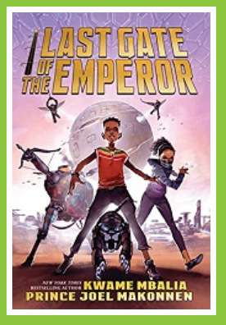
The last gate of the emperor

Often in trouble for his thrill-seeking antics and smart mouth, those same qualities make Yared a star player of the underground augmented reality game, The Hunt for Kaleb's Obelisk. But when a change in the game rules prompts Yared to log in with his real name, it triggers an attack that rocks the city. In the chaos, Uncle Moti disappears. Suddenly, all the stories Yared's uncle told him as a young boy are coming to life, of kingdoms in the sky and city-razing monsters. And somehow Yared is at the centre of them. Together with Besa and the Ibis - a game rival turned reluctant ally - Yared must search for his uncle... and answers to his place in a forgotten, galaxy- spanning war.

Uma and the answer to absolutely everything

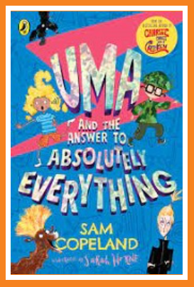
Uma has many questions: How can I save my home from being sold? Will my dad ever start talking again? But since her mum died, she has been short on answers. Then she finds an earpiece with an amazing AI called Athena. Now Uma has the answer to every question and she and her best friend Alan are going to use Athena to save their village and her father.

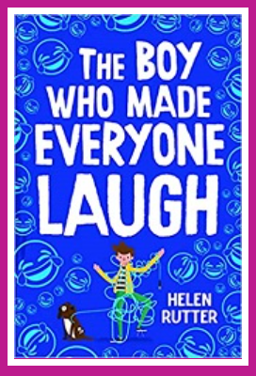
The boy who made everyone laugh

Billy Plimpton is an eleven-year-old boy with a big dream. He wants to be a stand-up comedian when he grows up: delivering pinpoint punch-lines and having audiences hang on his every hilarious word. A tough career for anyone, but surely impossible for Billy, who has a stammer. How will he find his voice, if his voice won't let him speak?

