RECEPTION, YEAR 1 / 2: What’s The Story?

What happened to you?
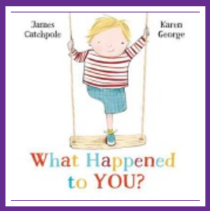
This is the experience of one-legged Joe, a child who just wants to have fun in the playground. However, he is constantly seen first for his disability when all he wants to do is play pirates. He gets very angry and tries to make his friends realise he is more than the number of limbs he has. Finally, the penny drops, and the children realise that Joe is playing a really good imaginative game, one they can join in with, and have great fun. At the end of the book the author tells us about losing his own leg and so we have no doubt that this reflects his authentic lived experience.

The best worst day ever

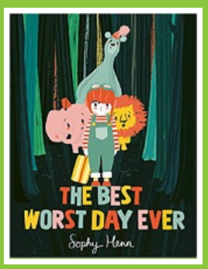
Arthur is having the WORST DAY EVER - so he runs away – right to the end of the garden. When he starts to feel hungry and he is convinced his hair has grown he decides he must go home. However, his journey back is full of surprises. A forest has grown in his garden and he meets some amazing animals. Each animal starts off roaring, or stomping, Arthur joins in with them. However, their unhappy stomps and noises turn to fun and happier play. At last, they find the front door to Arthur’s home, and even though all the animals agree it has been the best worst day ever, they all have homes to go to.

The Pet

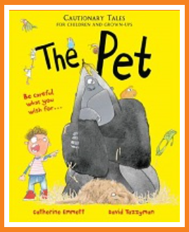
Digby David wants a pet, but not just any pet - it has to be TWICE as big as Reuben's guinea pig and even better than Lily Jean's cat. Digby David's Daddy does what he's told, and soon Digby has a guinea pig, which he loves with all his heart... for half a day. Digby demands bigger and better, Daddy's hair gets greyer and greyer, and when Digby's dog gets boring too, he insists Daddy buy him... a gorilla! A laugh-out-loud cautionary tale (for children and grown-ups) with a 'be careful what you wish for' message, especially if you wish for a gorilla and don't look after it properly!

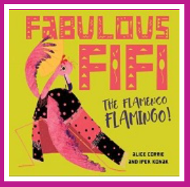
Fabulous Fifi

When Fifi tries to dance in front of the other flamingos, her flappy, flippy-floppy legs fail and they all fall about laughing at her. As she sets off in her quest to find her calling, she discovers the Flamenco Fiesta. The crowds all love Fifi's unique style of dancing and she becomes a fabulous, fantastic fashionable 'Flamenco Flamingo'! A tongue, twisting, read-aloud debut from author Alice Corrie with playful and vibrant illustrations. This funny story of Fifi the Flamenco with its celebration of Hispanic and Latino culture and pure fabulousness also tells a tale of great perseverance.

Here be dragons

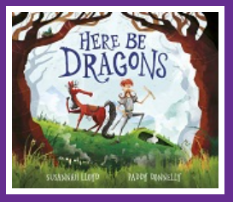
A knight is on a mission - to find and slay a dragon. The other knights have told him that there's no such thing as dragons, but he doesn't care. For he has a map, and the map says: HERE BE DRAGONS. He travels right to the spot marked 'X', past treasure, suspicious bones and many signs telling him to turn back. He wanders up and down a huge, spiky hill (the dragon's back) shouts into a burrow (the dragon's nose) and eventually walks into a cave (the dragon's mouth)... Will the hapless knight see the dragon before it's too late?!

Duck, Duck, Dad

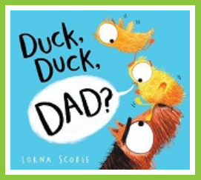
Out for a walk, Ralph the dog stumbles across an egg. He decides that the best thing for him to do is walk right on by. But, CRACK! the egg hatches, right then and there! What's inside? A very cute, very fluffy little duckling, and a though Ralph isn't sure he wants a duckling, the duckling is definitely sure it wants Ralph! When Ralph now finds himself becoming a Dad to this flock of ducklings it leads to lots of mix-ups, laughter and a lot of love.

I don't like books. Never. Ever. The end

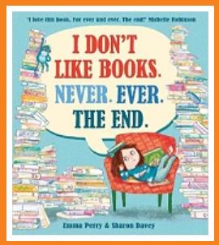
Mabel HATES books. She gets given loads of them but has no interest in reading them whatsoever. Instead of reading them, she uses them for all sorts of things, from juggling to sledging, but she NEVER looks at the stories inside. One night, the books have had enough and piled up in her bedroom they come alive. The stories jump out of their covers and off the pages so that they can show Mabel their story worlds. She is intrigued by a detective adventure, excited by the chance to board a spaceship and take a trip to the moon, delighted by the thought of accompanying a knight on his quest to seek castles and to duel with dragons. However, there is no way she can find out what happens next in these stories unless she begins to read the books!

What about me? Said the flea

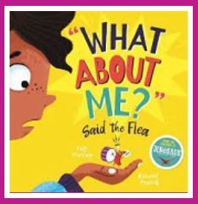
A flea struggles to get the attention of a little girl who he wants to write his story. Luckily for her there's a whole host of potential picture-book characters who want to be the star of her story and make their cases convincingly. There's the magical, proud unicorn with sparkly hooves and a glittery horn. There are the big, burly bears hosting a picnic, the loveable llamas in pyjamas, the stylish sloth, the lion, the penguins, and even a roar-some, claw-some dinosaur... But, unnoticed by the little girl, an even littler flea is hopping and jumping around, hoping to be the one she chooses to write a story about. "What about me?" it cries. With all the big characters and commotion, will the flea ever be noticed?

